Chemistry Unit 3/4 2020
Task title: Content Assignment - Protein chemistry report and quiz

UNIT: 3 and 4 Task 10

UNIT CONTEXT: Carbohydrates, amino acids and proteins.

TASK 10: Part 1 - Content Assignment. Total weighting 1%
Part 2 – Validation Quiz. Total weighting 4%

Time Plan and Description:
- Class time to answer the assignment questions.
- One period to answer a quiz which associated with the assignment.

Requirements for assessment | Weighting for task
- Assignment | 20
- Validation Quiz | 80
 | 100 Total


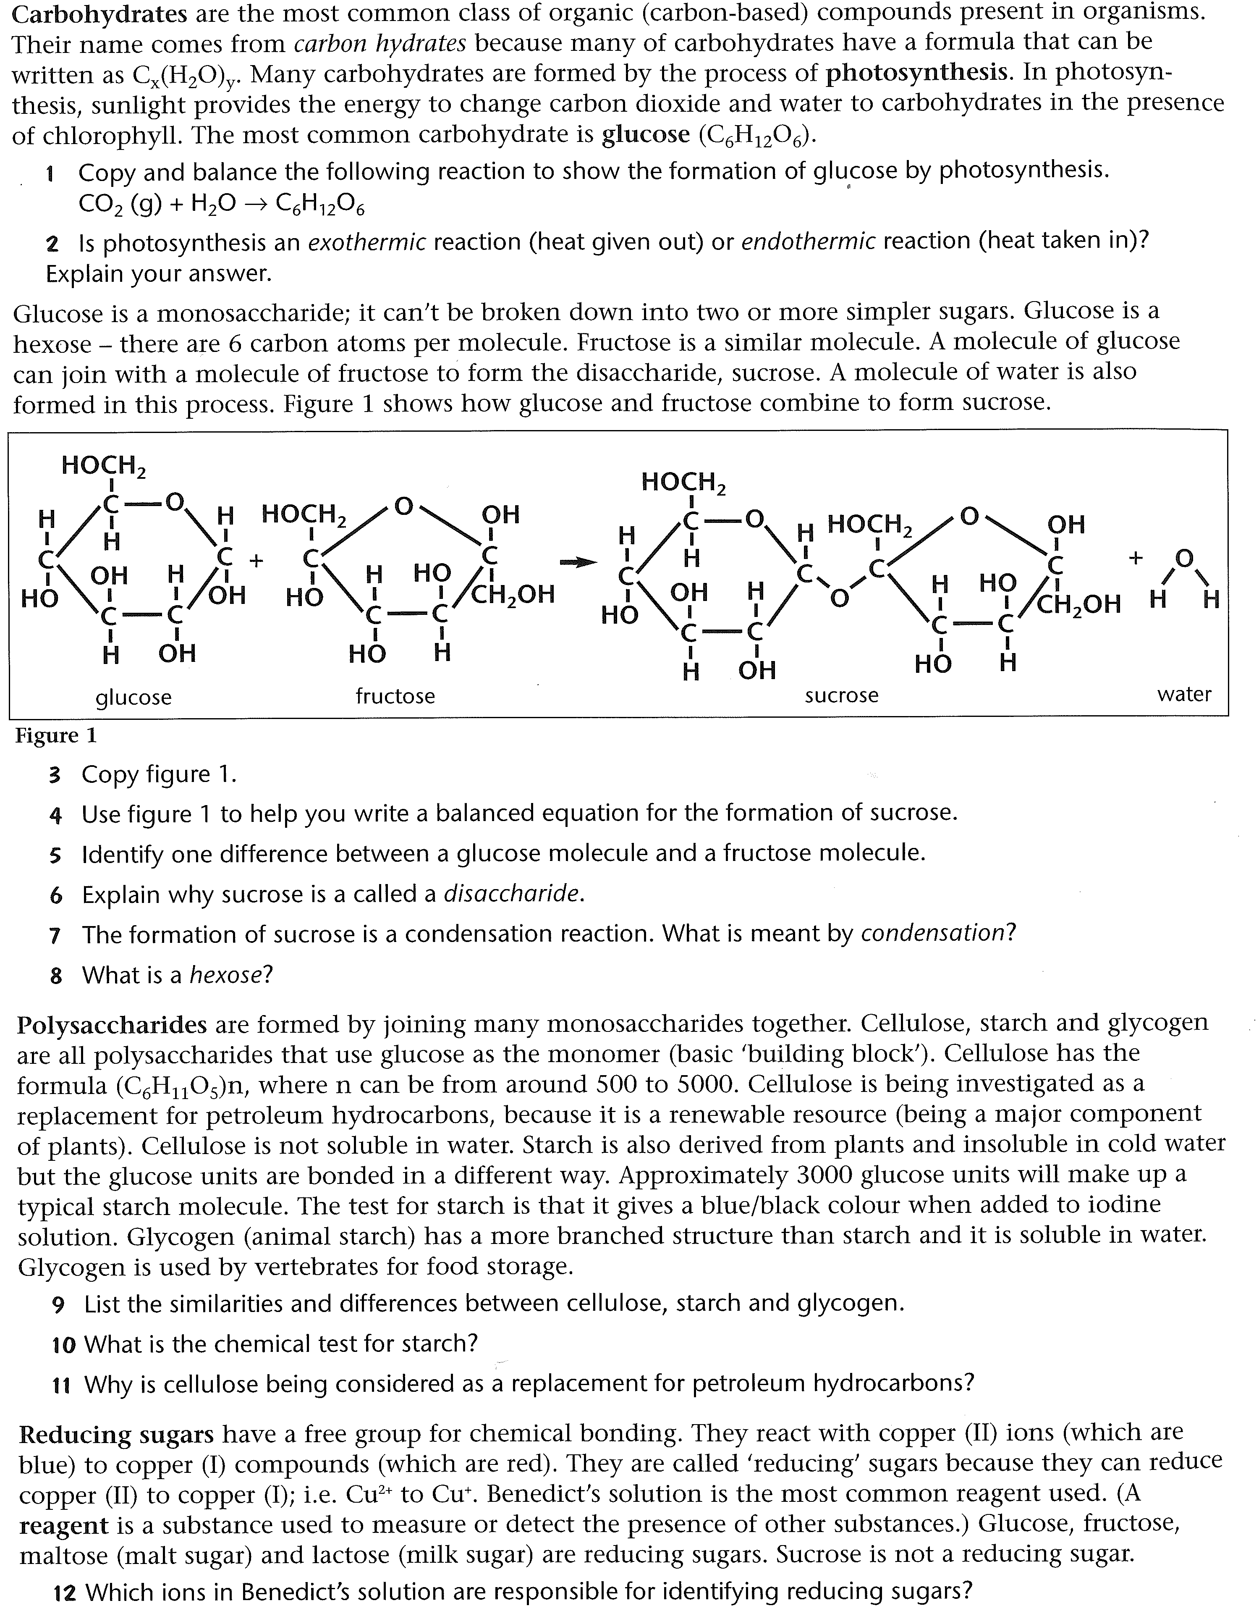
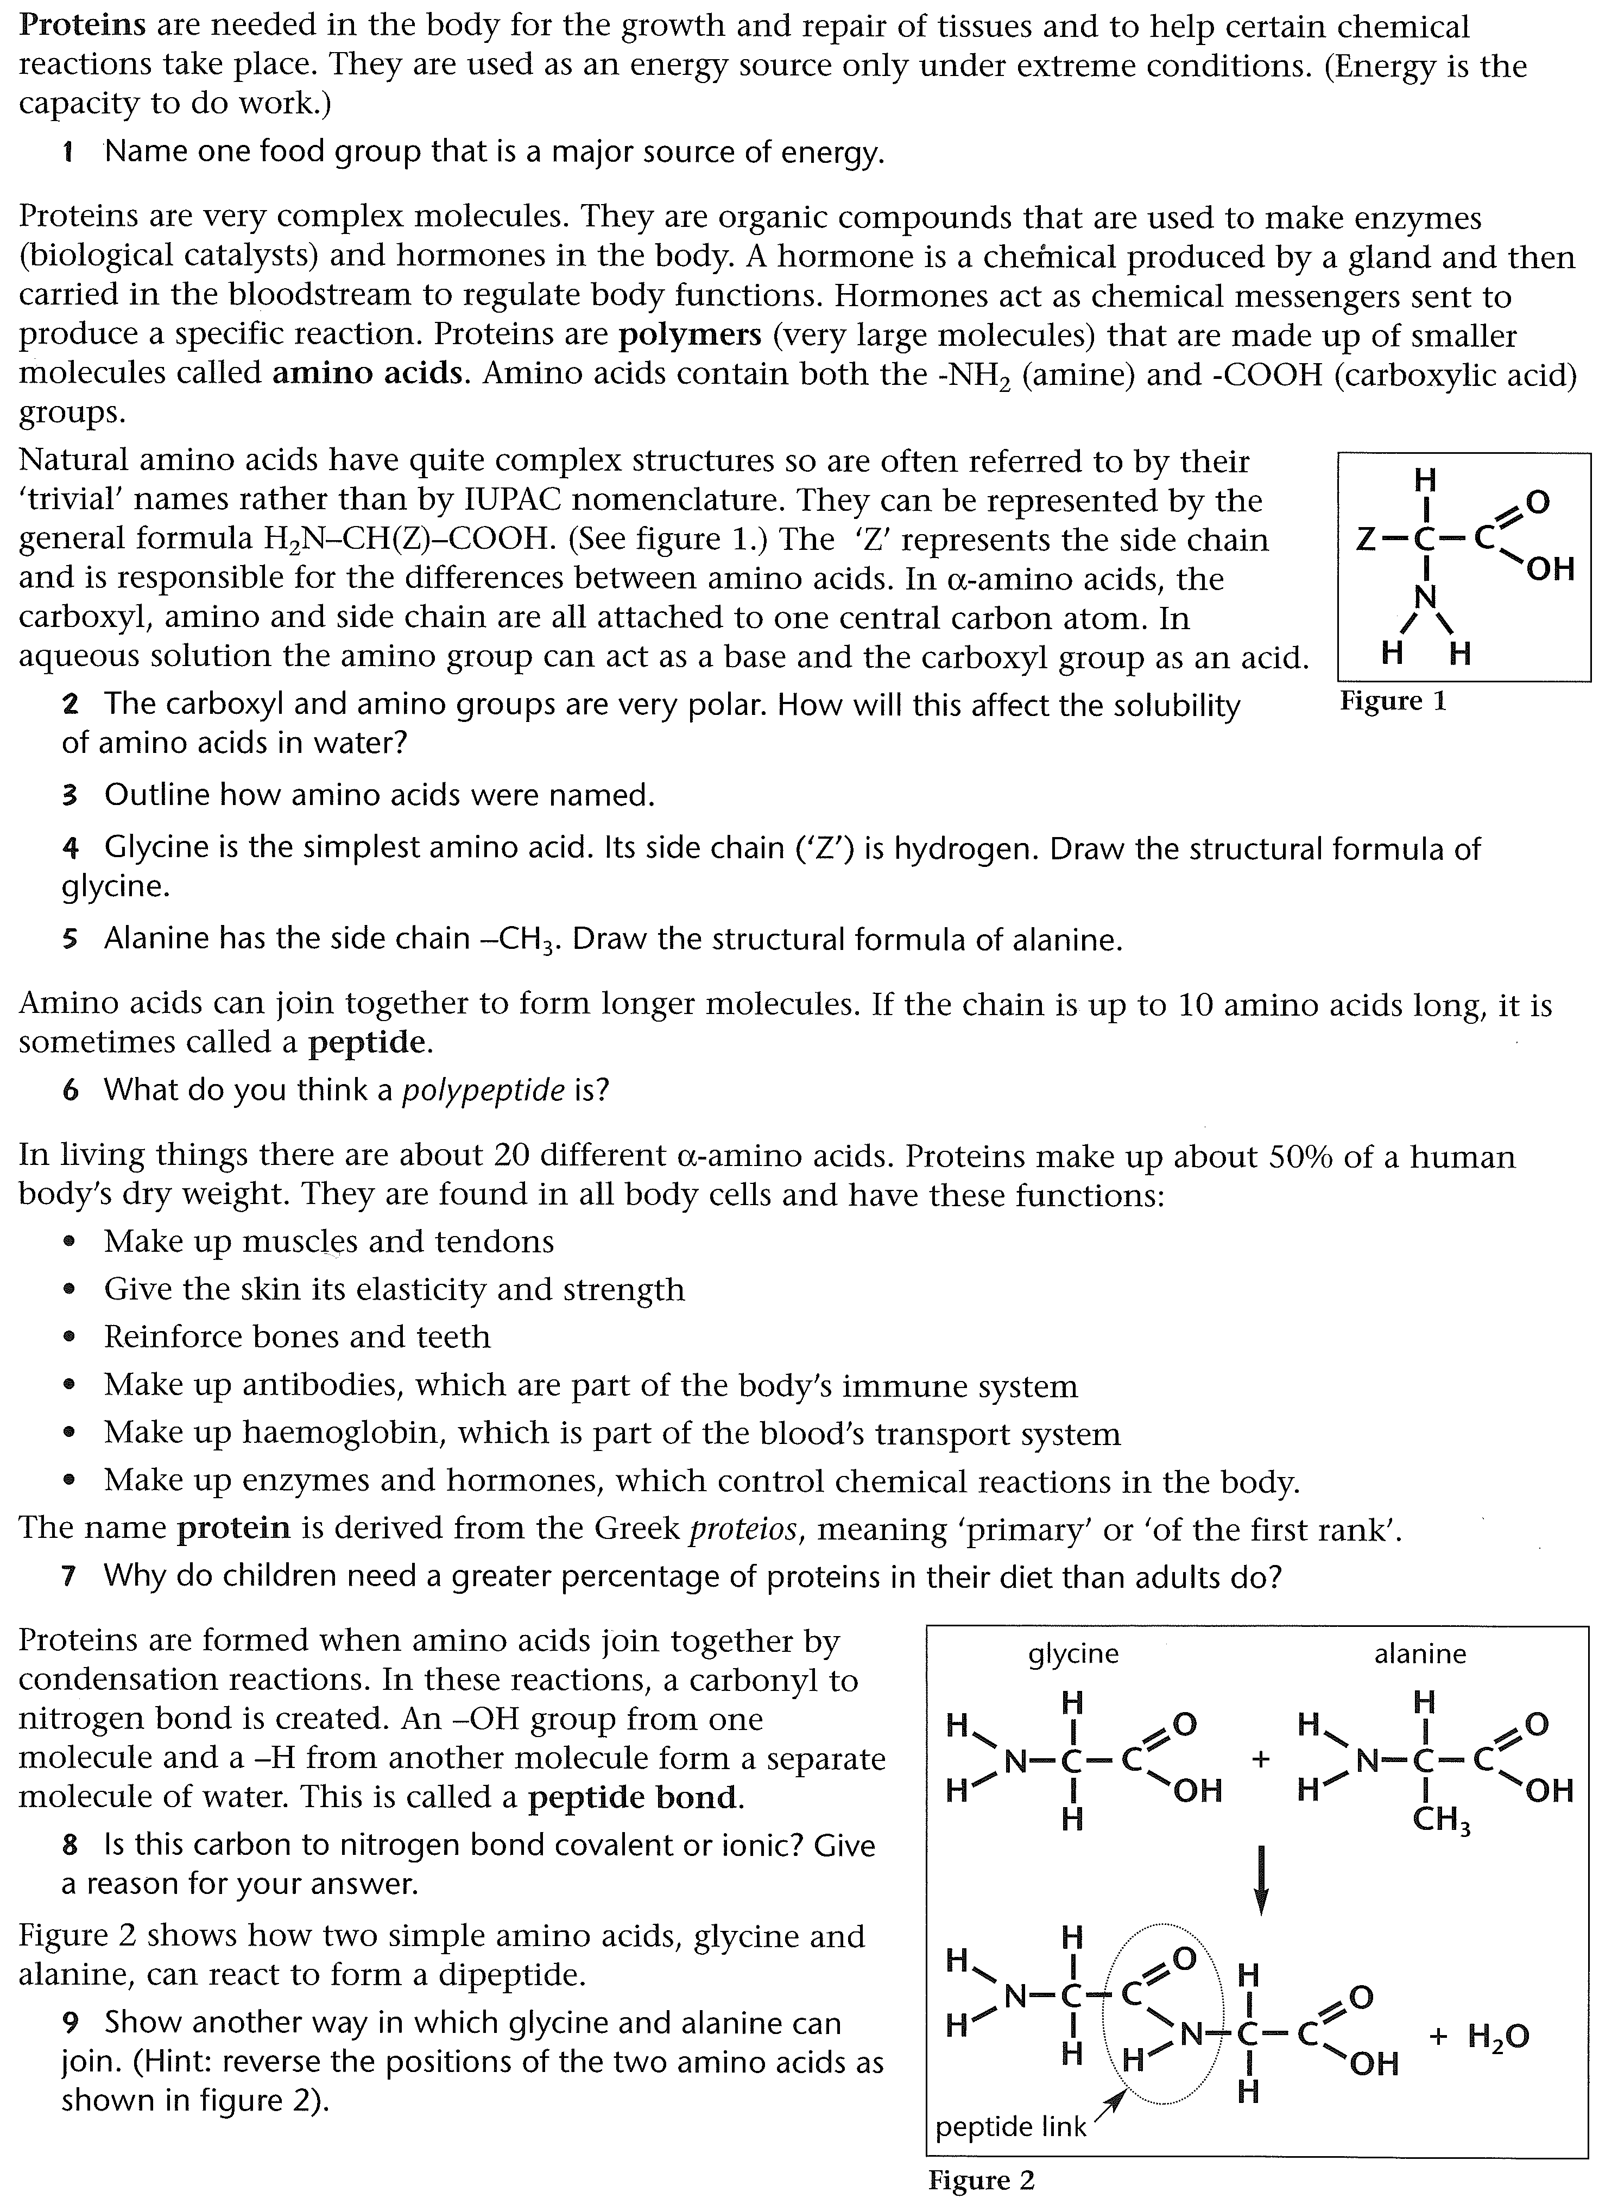
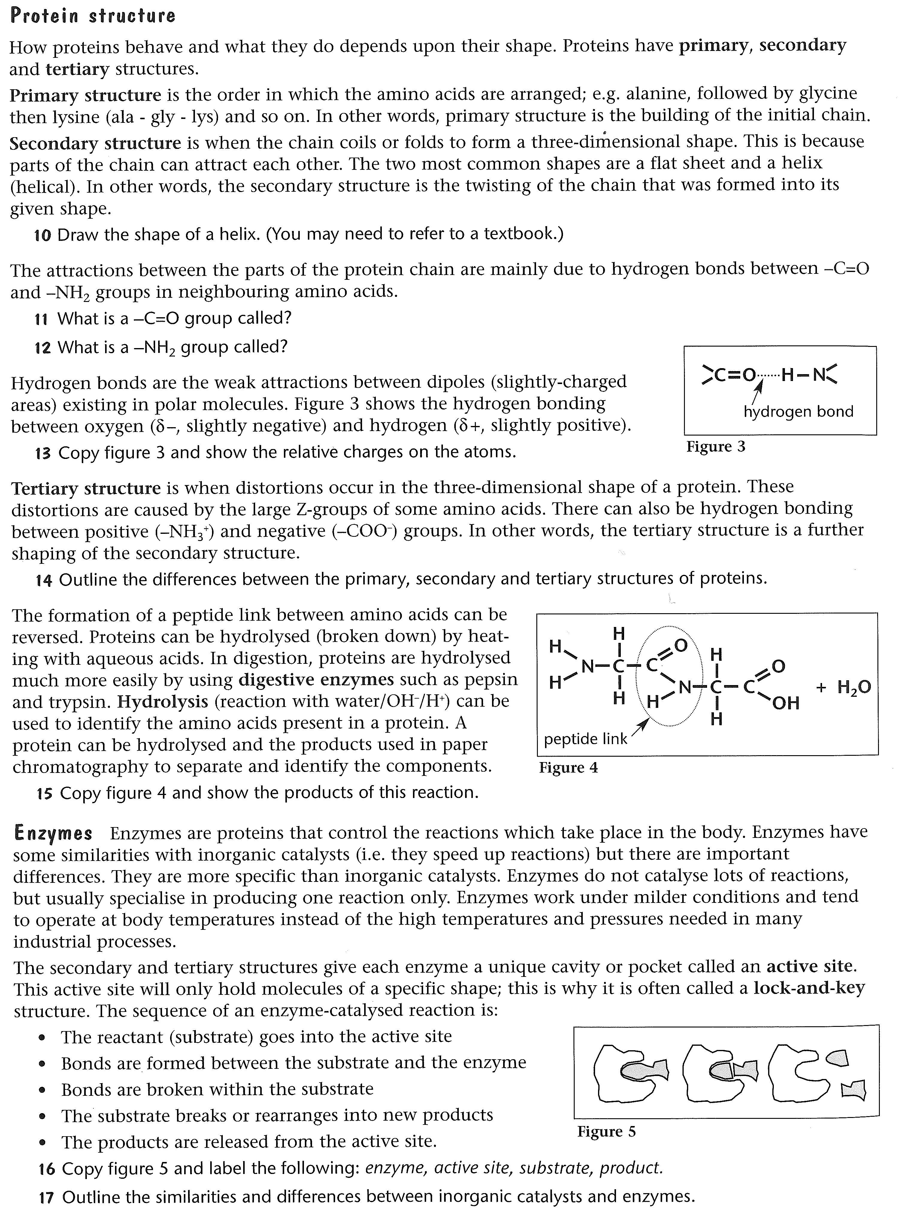

Biuret Test for Proteins (ref: http://brilliantbiologystudent.weebly.com/biuret-test-for-protein.html)

BACKGROUND: What is the Biuret Test for Proteins?
The Biuret Test is often used to determine the presence of peptide bonds in protein. As a student you will most likely will be testing for the presence of protein in foods.

The Biuret test for proteins may also be extended to quantitatively measure the concentration of total protein using spectrometric methods.
The Biuret reagent is the sole reagent in the Biuret Test for proteins. The Biuret reagent contains
- Hydrated Copper sulphate
- Potassium hydroxide solution
- Potassium sodium tartrate

Are the alternative reagents for the Biuret Test for Proteins?
As an alternative to the Biuret Reagent, either of the following solutions may be used to yield comparable results.
- Sodium Hydroxide and Copper Sulphate Solutions
- Fehling’s Solutions A and B

PROCEDURE
Three procedures are outlined below using different reagents.
For each of the procedures, a liquid sample must be prepared from solid foods as follows.
PREPARATION OF LIQUID SAMPLE
Crush the solid food, add a little de-ionized water and decant the liquid. This liquid should be used for the food test. The quantity of food crushed and water used depends on the number of tests to be conducted.

What is the procedure for the Biuret Test for proteins using Biuret Reagent?
Add 2 cm3 of the liquid food sample* to a clean, dry test tube
- Add 2 cm3 of Biuret Reagent.
- Repeat steps the steps above with de-ionized water to prepare a negative control and with albumin (egg white) to prepare a positive control.
- Shake well and allow the mixture to stand for 5 minutes
- Observe any colour change.

What is the procedure for the Biuret Test for protein using sodium hydroxide and copper sulphate solutions?
- Add 1 cm3 of sodium hydroxide solution (40% or bench solution) and 1% copper (II) sulphate solution drop wise (one drop at a time) to the food sample
- Repeat the steps above with de-ionized water to prepare a negative control and with albumin (egg white) to prepare a positive control.
- Shake well and allow the mixture to stand for 5 minutes
- Observe any colour change.

What is the procedure for the Biuret Test for protein using Fehling's A and B Solutions?
Fehling's A and B should be freshly prepared. Fehling’s A is copper (II) solution and Fehling's B is a mixture of sodium potassium tartrate and sodium hydroxide solution.
- 1cm3 of each solution – A and B – should be added to the food sample.
- Repeat steps 1 and 2 with de-ionized water to prepare a negative control and with albumin (egg white) to prepare a positive control.
- Shake well and allow the mixture to stand for 5 minutes
- Observe any colour change.

OBSERVATIONS & INTERPRETATION

What are the expected results in the Biuret Test for proteins?
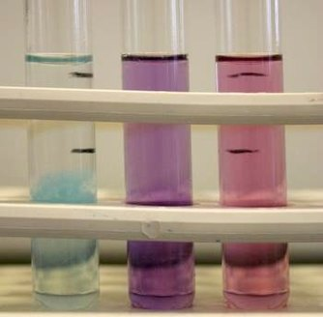
Look for colour changes in the solution. They range from no colour change (blue) to pink to deep violet.
Colour changes are best visualized against a white background such as a white tile or a sheet of paper.

OBSERVATIONS  No change (solution remains blue )  The solution turns from blue to violet (deep purple)  The solution turns from blue to pink | INTERPRETATION  Proteins are not present  Proteins are present  Peptides are present (Peptides or peptones are short chains of amino acid residues)

DISCUSSION
QUESTIONS & ANSWERS

Who or what is Biuret?
The biuret reagent is not named after z famous scientist but after a substance called biuret (H2NC(O)NHC(O)NH2). Biuret is the result of the condensation of 2 molecules of urea. The reagent is so named because the peptide bonds in biuret give a positive result for the test.

What is the composition of the Biuret reagent?
Biuret Reagent contains
- Hydrated Copper sulphate. This provides the Cu (II) ions which form the chelate complex. Cu (II) ions give the reagent its characteristic blue colour.
- Potassium hydroxide solution does not participate in the reaction but provides the alkaline medium.
- Potassium sodium tartrate (KNaC4H4O6·4H2O) – stabilizes the chelate complex.

What is the principle - or basis - of the Biuret Test for proteins?
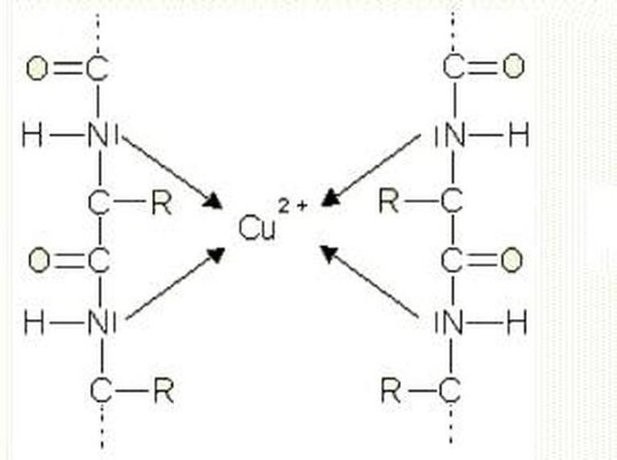
The Biuret test is based on the ability of Cu (II) ions to form a violet-coloured chelate complex with peptide bonds (-CONH- groups) in alkaline conditions.
Lone electron pairs from 4 nitrogen atoms in the peptide bond coordinate a copper (II) ion to form the chelate complex.
The chelate complex absorbs light at 540 nm so appears violet. Hence a colour-change from blue to violet indicates that proteins are present.
The greater the concentration of peptide bonds, the greater the colour intensity. If the concentration of peptide bonds is low – such as when short-chain peptides are present - the colour change is from blue to pink.

Why would amino acids give a negative result in the Biuret Test for Proteins?
As 2 peptide bonds are required for the formation of the chelate complex, single amino acids - no peptide bonds present - and dipeptides - only 1 peptide bond present – give a negative result.

How can the Biuret Test be extended to quantitatively measure the concentration of protein?
According to the Beer-Lambert Law, the absorption of the sample is directly proportional to the concentration of the species – in this case peptide bonds. Hence absorption spectroscopy using a spectrophotometer is a quantitative method which can be used to determine the concentration of total protein, following the Biuret test.

END OF ASSIGNMENT

